HEALTH CARE DATABASE

CITY MD URGENT CARE DATABASE SYSTEM

Table of Contents

Deliverable 3
Introduction 2
Current Problems 2
Development Motivation 2
Benefits and Users 3
Business Rules 3
User Requirements 5
Entity Relation Diagram 6

Introduction
Current Problems
Areas of Focus:
- Urgent Care Health Sector Staff Shortage and High Patient Volume

The urgent care sector is indispensable for providing immediate medical attention to patients with non-life-threatening conditions. However, the increasing demand for urgent care services, combined with staff shortages, presents a significant challenge. With limited personnel managing large volumes of patients, there is a heightened need for efficient data management systems to streamline operations and ensure high-quality care.
These challenges are further worsened by inefficient and outdated data management practices, leading to operational inefficiencies, compromised patient care, and increased workload on existing staff.
The current data management problem am seeking to address here are Staff shortages and overwhelming administrative burden, inefficient data retrieval or patient flow management systems and lack of real-time data access, The proposed database would be tailored to address these issues, ensuring data integrity, reduce additional strain on already overworked staff, reducing redundancy, and improving overall operational efficiency.

Development Motivation
Motivation for the Database is to address these challenges faced by Urgent care such as over-working of staffs within the urgent care system, the database is under development with the hope of helping and allowing staffs to access up to date info on patients’ treatment plan, treatment status and availability of resources and provide efficient day to day operations allowing seamless data sharing with other healthcare providers which will improve continuity of improved healthcare.

Benefits & Users
The potential benefit of this database will yield numerous benefits such as reduced staff workload, faster decision making with fast access to accurate patient records and mainly improved patient flow with the use of this database which will manage patient wait time leading to shorter wait times, room assignments for patients, reduce cost and improve operational efficiency with enhanced patient care in the urgent care.
The database will also improve data accuracy and reduce data redundancy.
For this database, the benefit also includes Enhancing operational efficiency and Streamlining data management processes.
The end goal and benefit will be to facilitate better decision-making through improved data accessibility and availability, remove data anomalies and lastly Ensures data integrity.
The potential users of the newly to be integrated and developed database for the urgent care will be urgent care and health care providers such as the Doctors, Nurses, Technicians, this will also include the urgent care Administrators, other healthcare facilities and lastly the Patients.

Business Rules

City MD Urgent care has a vast number of staff. The attribute of staff is Staff_ID (Primary Key) with other attributes such as First Name, Last Name, Role, Address, Email, Hire Date and Phone Number
The Staff entity has three subtypes’ Doctors, Nurses and Administrator. A Staff may be or may not be either a Doctor, Nurse or Administrator, but a staff in one of these subtypes cannot be at the same time one of the other subtypes.

Also, all staff is managed by at least one manager whom they report to.

Doctor-Nurse-Patient Relationship
Doctors, Nurses and Administrators are employees of the City MD urgent care, the qualifications and specialization of each Doctors must be tracked by the database. Nurses shift hours must be tracked by the database as well.
Administrators are responsible for patients related activities such as registering patients, patient appointment, placing doctor patients’ medication order, managing staff schedules and issuing patient bills for service.
Every patient is assigned to a Doctor and Nurse, each patient visitation with the date and time and assigned to a room during examination.
The primary attribute for the Patient entity will be Patient ID as each registered patient is assigned to a room.
Doctors are primarily responsible for patient diagnostics, test type, test result and other attributes, a doctor can attend to one or more patient during the visitation while a patient can only have one or no doctor.

Every Nurse is assigned to at one or many patients, while each patient must be assigned to at least one Nurse
Staff-Visit Relationship
A staff such as a doctor, nurse can attend to multiple visits for patient, but each visit must be assigned to one staff

Visit-Billing Relationship
Every patient visit generates one bill, and each bill must correspond to one visit.
The billing will have self-payment and insurance payment as subtype, and health insurance is issued to one patient, but patient do not need to have health insurance and can opt out for self-payment option

Patient -Appointment Relationship
Every patient can schedule multiple appointments, but each appointment must have only one patient.

Appointment-Treatment Relationship
Each appointment can have zero to multiple appointment, and each treatment can also be associated with zero to many appointments.

Diagnostics-Visit Relationship
While each patient can have one to multiple diagnostics, each patient must have one visit.

User Requirements
Database users will be the following type of City MD Staffs: Doctors, Nurses, Administrator
Users of the City MD Database will have access to patient appointment information, diagnostics tests, patient information, medical history and test results.

Enhanced Entity Relation Diagram

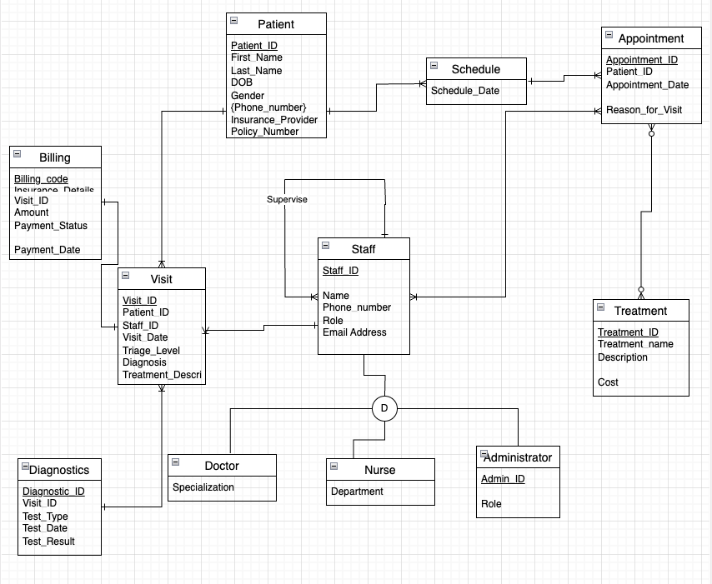

THIRD NORMAL FORM

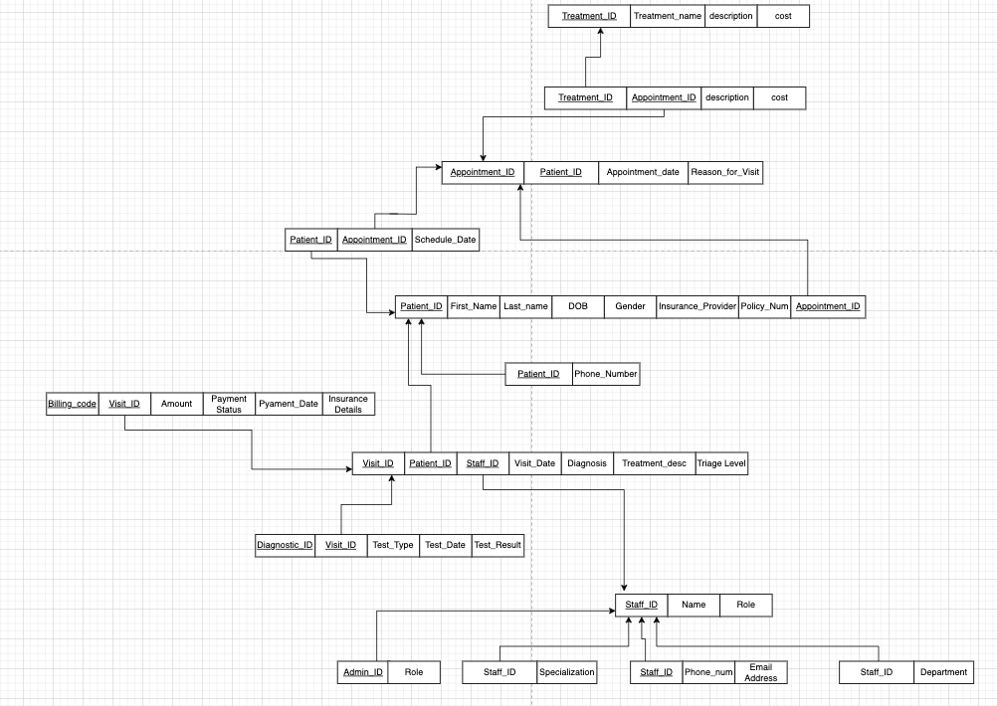

SQL TABLES

CREATE TABLE STAFF (
STAFF_ID VARCHAR(25) NOT NULL,
SUPERVISOR VARCHAR(25),
STAFF_NAME VARCHAR(25),
STAFF_ADDRESS VARCHAR(30),
STAFF_ROLE VARCHAR(30),
EMAIL_ADDRESS VARCHAR(20),
PHONE_NUMBER VARCHAR(15),
CONSTRAINT STAFF_PK PRIMARY KEY(STAFF_ID));

CREATE TABLE PATIENT (
PATIENT_ID VARCHAR(10) NOT NULL,
FIRST_NAME VARCHAR(25),
LAST_NAME VARCHAR(25),
GENDER VARCHAR(10),
PHONE_NUMBER VARCHAR(15),
POLICY_NUMBER VARCHAR(30),
INSURANCE_PROVIDER VARCHAR(25),
DOB DATE,
CONSTRAINT PATIENT_PK PRIMARY KEY(PATIENT_ID));

CREATE TABLE TREATMENT (
TREATMENT_ID VARCHAR(10) NOT NULL,
TREATMENT_NAME VARCHAR(100),
DESCRIPTION VARCHAR(100),
COST VARCHAR(10),
CONSTRAINT TREATMENT_PK PRIMARY KEY(TREATMENT_ID));

CREATE TABLE VISIT (
VISIT_ID VARCHAR(10) NOT NULL,
PATIENT_ID VARCHAR(10) NOT NULL,
#BILLING_CODE VARCHAR(10) NOT NULL,
STAFF_ID VARCHAR(10) NOT NULL,
#DIAGNOSTIC_ID VARCHAR(10) NOT NULL,
VISIT_DATE DATE,
TRIAGE_LEVEL VARCHAR(10),
DIAGNOSIS VARCHAR(100),
TREATMENT_DESCRIPTION VARCHAR(100),
CONSTRAINT VISIT_PK PRIMARY KEY (VISIT_ID),
CONSTRAINT VISIT_FK1 FOREIGN KEY (PATIENT_ID) REFERENCES PATIENT
(PATIENT_ID),
#CONSTRAINT VISIT_FK3 FOREIGN KEY (DIAGNOSTIC_ID) REFERENCES DIAGNOSTICS
#(DIAGNOSTIC_ID),
CONSTRAINT VISIT_FK4 FOREIGN KEY (STAFF_ID) REFERENCES STAFF
(STAFF_ID));

CREATE TABLE DIAGNOSTICS (
DIAGNOSTIC_ID VARCHAR(10) NOT NULL,
VISIT_ID VARCHAR(10) NOT NULL,
TEST_DATE DATE,
TEST_TYPE VARCHAR(100),
TEST_RESULT VARCHAR(100),
CONSTRAINT DIAGNOSTICS_PK PRIMARY KEY(DIAGNOSTIC_ID, VISIT_ID),
CONSTRAINT DIAGNOSTICS_FK FOREIGN KEY (VISIT_ID) REFERENCES VISIT
(VISIT_ID));

CREATE TABLE BILLING (
BILLING_CODE VARCHAR(10) NOT NULL,
VISIT_ID VARCHAR(10) NOT NULL,
INSURANCE_DETAILS VARCHAR(25),
AMOUNT VARCHAR(10),
PAYMENT_STATUS VARCHAR(25),
PAYMENT_DATE DATE,
CONSTRAINT BILLING_PK PRIMARY KEY(BILLING_CODE, VISIT_ID),
CONSTRAINT BILLING_FK FOREIGN KEY (VISIT_ID) REFERENCES VISIT(VISIT_ID)
);

ALTER TABLE VISIT ADD COLUMN BILLING_CODE VARCHAR(10);
ALTER TABLE VISIT ADD CONSTRAINT VISIT_FK2 FOREIGN KEY (BILLING_CODE, VISIT_ID) REFERENCES BILLING(BILLING_CODE, VISIT_ID);

CREATE TABLE DOCTOR (
SPECIALIZATION VARCHAR(25),
STAFF_ID VARCHAR(10) NOT NULL,
CONSTRAINT DOCTOR_PK PRIMARY KEY (STAFF_ID),
CONSTRAINT DOCTOR_FK FOREIGN KEY (STAFF_ID) REFERENCES STAFF(STAFF_ID)
);

CREATE TABLE NURSE (
DEPARTMENT VARCHAR(25),
STAFF_ID VARCHAR(10) NOT NULL,
CONSTRAINT NURSE_PK PRIMARY KEY (STAFF_ID),
CONSTRAINT NURSE_FK FOREIGN KEY (STAFF_ID) REFERENCES STAFF(STAFF_ID)
);

CREATE TABLE ADMINISTRATOR (
ADMIN_ID VARCHAR(10) NOT NULL,
STAFF_ID VARCHAR(10) NOT NULL,
ROLE varchar(25),
CONSTRAINT ADMINISTRATOR_PK PRIMARY KEY (STAFF_ID),
CONSTRAINT ADMINISTRATIVE_FK FOREIGN KEY (ADMIN_ID) REFERENCES STAFF
(STAFF_ID));

CREATE TABLE APPOINTMENT (
APPOINTMENT_ID VARCHAR(10) NOT NULL,
PATIENT_ID VARCHAR(10) NOT NULL,
STAFF_ID VARCHAR(10) NOT NULL,
TREATMENT_ID VARCHAR(10) NOT NULL,
APPOINTMENT_DATE DATE,
SCHEDULE_DATE DATE,
REASON_FOR_VISIT VARCHAR(100),
COST VARCHAR(10),
CONSTRAINT APPOINTMENT_PK PRIMARY KEY(APPOINTMENT_ID),
CONSTRAINT APPOINTMENT_FK1 FOREIGN KEY (PATIENT_ID) REFERENCES PATIENT
(PATIENT_ID),
CONSTRAINT APPOINTMENT_FK2 FOREIGN KEY (STAFF_ID) REFERENCES STAFF
(STAFF_ID),
CONSTRAINT APPOINTMENT_FK3 FOREIGN KEY (TREATMENT_ID) REFERENCES TREATMENT
(TREATMENT_ID));

DATA FOR THE SQL TABLES

#PATIENT

INSERT INTO PATIENT VALUES ( 'CM34240', 'JOHN','MENSAH', 'MALE','646-506-200','CG166563', 'CIGNA','1991-07-01');
INSERT INTO PATIENT VALUES ( 'CM34941', 'BOLAJI','MUYIWA', 'MALE','655-556-7111','BC126563', 'BLUECROSS','1990-12-24');
INSERT INTO PATIENT VALUES ( 'CM34742', 'JOHN','TUNJI', 'MALE','646-123-7111','SEIU165563','1199SEIU','1981-02-03');
INSERT INTO PATIENT VALUES ( 'CM34012', 'TOLA','SEUN', 'FEMALE','646-800-7111','AT166503', 'AETNA','1988-09-02');
INSERT INTO PATIENT VALUES ( 'CM34200', 'GBENGA','SEGUN', 'MALE','347-556-7111','AF106563', 'AFFINITY','1992-11-15');
INSERT INTO PATIENT VALUES ( 'CM31142', 'SANDHYA','GOPISETTY','FEMALE','800-556-7111','UN169563', 'UNITEDHEALTHCARE','1993-03-21');
INSERT INTO PATIENT VALUES ( 'CM34542', 'ARMINDA','SINGH','MALE','817-556-7111','EB164063', 'EMBLEM','1987-10-15');
INSERT INTO PATIENT VALUES ( 'CM34842', 'GOPAL','BOGANA','MALE','600-556-0511','HE168163', 'HEALTHFIRST','1981-01-13');
INSERT INTO PATIENT VALUES ( 'CM34942', 'CHIKA','UZOKWULW', 'MALE','247-556-7111','ME067563','METROPLUS','1982-08-10');
INSERT INTO PATIENT VALUES ( 'CM34042', 'CAESAR','ADOMAKO','MALE','425-556-7921','OS166563', 'OSCAR HEALTH','2000-04-10');

#STAFF #DOCTOR AND NURSE
INSERT INTO STAFF VALUES ('SM34242','WAYNE RONNEY', 'SUNDAY MUYIWA','123 SWANSEA ST,NY', 'DOCTOR','bmuyiwa@citymd.com', '646-555-9681' );
INSERT INTO DOCTOR VALUES ( 'CARDIOLOGY','SM34242' );
INSERT INTO STAFF VALUES ( 'TO31242','SATYA NADELLA', 'TUNJI OLAMUYIWA','466 JAMAICA AVE,NY', 'DOCTOR','TMUYIWA@citymd.com','347-556-7111' );
INSERT INTO DOCTOR VALUES ( 'ER','TO31242' );
INSERT INTO STAFF VALUES ( 'NG14092', 'ELON MUSK','NATHAN GREGORY','123 ONE WAY,REDMOND,NY','DOCTOR','NGREGORY@citymd.com','247-556-7111');
INSERT INTO DOCTOR VALUES ( 'GENERAL MEDICINE','NG14092' );
INSERT INTO STAFF VALUES ( 'EP10042', 'TOM JOLLY','ETHAN PEYTON','45 MICROSOFT WAY,NY', 'DOCTOR','EPEYTHON@citymd.com','547-556-7111');
INSERT INTO DOCTOR VALUES ( 'FAMILY MEDICINE','EP10042' );
INSERT INTO STAFF VALUES ( 'LA19042','SCOTT GRAHAM', 'LOLA ASHLEY','869 PULSAKI AVE,NY', 'NURSE','LASHLEY@citymd.com','547-4007-111');
INSERT INTO NURSE VALUES ( 'TRIAGE','LA19042' );
INSERT INTO STAFF VALUES ( 'TK15542','MANEESH BABLANI', 'TOLA KARI', '456 ORLANDO ST, NY','NURSE','TKARI@citymd.com','718-400-7111' );
INSERT INTO NURSE VALUES ( 'PEDIATRIC','TK15542' );
INSERT INTO STAFF VALUES ( 'MR13442','AMIT KHAN', 'MALANDA RUST','101 FOREST AVE, NY', 'NURSE','MRUST@citymd.com','500-420-7111');
INSERT INTO NURSE VALUES ( 'TRIAGE','MR13442');
INSERT INTO STAFF VALUES ( 'SC10742', 'MALA ANAND','SCOTT COTA','189 ALVIN ST,NY', 'NURSE','MANAND@citymd.com','526-400-7111');
INSERT INTO NURSE VALUES ( 'PEDIATRIC','SC10742' );

#TREATMENT
INSERT INTO TREATMENT VALUES ( 'CMU10101','Immunotherapy','therapy for immuno diseases','$10000' );
INSERT INTO TREATMENT VALUES ( 'CMU10102','Blood transfusion','2 blood transfusion','$12000' );
INSERT INTO TREATMENT VALUES ( 'CMU10103','IV fluid administration','dehydration','$2000' );
INSERT INTO TREATMENT VALUES ( 'CMU10104','Pain management injection','headache and body pain','$1000' );
INSERT INTO TREATMENT VALUES ( 'CMU10105','Antibiotic therapy','infections through sex','$7000' );
INSERT INTO TREATMENT VALUES ( 'CMU10106','Steroid treatment','Kidney issues','$50000' );
INSERT INTO TREATMENT VALUES ( 'CMU10107','Chemotherapy infusion','Cancer of the lungs','$70000' );
INSERT INTO TREATMENT VALUES ( 'CMU10108','Anticoagulant therapy','Blood clot','$100000' );
INSERT INTO TREATMENT VALUES ( 'CMU10109','Ultrasound','Pregnancy','$5000' );
INSERT INTO TREATMENT VALUES ( 'CMU10110','Electrocardiogram','Chest Pain','$17000' );

#VISIT
INSERT INTO VISIT VALUES ( 'CMD1001','CM34240', 'TO31242','2025-01-07','URGENT','Pneumonia','Antibiotics azithromycin/ceftriaxone','CMD50010' );
INSERT INTO VISIT VALUES ( 'CMD1002','CM34941','SM34242', '2025-02-09','NOT-URGENT', 'HEADACHE','ASPRIN','CMD50011');
INSERT INTO VISIT VALUES ( 'CMD1003','CM34742','NG14092', '2025-02-20','IMMEDIATE', 'BLEEDING INTERNAL','MRI SCAN','CMD50012');
INSERT INTO VISIT VALUES ( 'CMD1004','CM34012','EP10042', '2025-01-17','EMERGENT', 'BROKEN LEG','CAT SCAN','CMD50013');
INSERT INTO VISIT VALUES ( 'CMD1005','CM34200','EP10042', '2025-01-27','IMMEDIATE', 'INFECTION INTERNAL','Endoscopy with cauterization','CMD50014');
INSERT INTO VISIT VALUES ( 'CMD1006','CM31142','NG14092', '2025-01-14','IMMEDIATE', 'SEPSIS','IV fluids resuscitation','CMD50015');
INSERT INTO VISIT VALUES ( 'CMD1007','CM34542','LA19042', '2025-03-07','EMERGENT', 'Urinary Tract Infection','Phenazopyridine for pain','CMD50016');
INSERT INTO VISIT VALUES ( 'CMD1008','CM34842','TK15542', '2025-03-10','URGENT', 'Rotator Cuff Tear','Physical therapy','CMD50017');
INSERT INTO VISIT VALUES ( 'CMD1009','CM34942','MR13442', '2025-03-22','URGENT', 'Hip Fracture','hemiarthroplasty','CMD50018');
INSERT INTO VISIT VALUES ( 'CMD1010','CM34042','SC10742', '2025-03-27','IMMEDIATE', 'Acute Appendicitis','Appendectomy','CMD50019');

#BILLING
INSERT INTO BILLING VALUES ( 'CMD50010','CMD1001', 'CIGNA','$2000','PAID', '2024-03-30' );
INSERT INTO BILLING VALUES ( 'CMD50011','CMD1002', 'BLUECROSS', '$5000','UNPAID', '2099-12-31' );
INSERT INTO BILLING VALUES ( 'CMD50012','CMD1003', '1199SEIU', '$10000','OVERDUE', '2025-03-10' );
INSERT INTO BILLING VALUES ( 'CMD50013','CMD1004', 'AETNA', '$20000','UNPAID', '2099-12-31' );
INSERT INTO BILLING VALUES ( 'CMD50014','CMD1005', 'AFFINITY', '$2500','PENDING', '2024-09-01' );
INSERT INTO BILLING VALUES ( 'CMD50015', 'CMD1006','UNITEDHEALTHCARE', '$12000','PARTIALLY PAID', '2025-02-28' );
INSERT INTO BILLING VALUES ( 'CMD50016','CMD1007', 'EMBLEM','$200','PAID', '2025-02-14' );
INSERT INTO BILLING VALUES ( 'CMD50017','CMD1008', 'HEALTHFIRST', '$4000','PAID', '2025-03-31' );
INSERT INTO BILLING VALUES ( 'CMD50018','CMD1009', 'METROPLUS', '$2000','FAILED', '2099-12-31' );
INSERT INTO BILLING VALUES ( 'CMD50019','CMD1010', 'OSCAR HEALTH', '$22000','UNPAID', '2099-12-31' );

#DIAGNOSTICS

INSERT INTO DIAGNOSTICS VALUES ( 'CMD20201','CMD1001','2025-03-21', 'Basic Metabolic Panel Blood Test', 'High Glucose: Diabetes' );
INSERT INTO DIAGNOSTICS VALUES ( 'CMD20202','CMD1002','2024-03-03', 'X-ray', 'Fracture visible' );
INSERT INTO DIAGNOSTICS VALUES ( 'CMD20203','CMD1003','2025-01-10', 'MRI ','Herniated disc');
INSERT INTO DIAGNOSTICS VALUES ( 'CMD20204','CMD1004','2025-02-03', 'Ultrasound ', 'Fetal heartbeat');
INSERT INTO DIAGNOSTICS VALUES ( 'CMD20205','CMD1005','2025-04-03', 'Echocardiogram ', 'Weak heart valve');
INSERT INTO DIAGNOSTICS VALUES ( 'CMD20206','CMD1006','2025-03-20', 'EEG ', 'Abnormal brain waves');
INSERT INTO DIAGNOSTICS VALUES ( 'CMD20207','CMD1007','2025-03-13', 'Urinalysis ', 'Nitrites: UTI');
INSERT INTO DIAGNOSTICS VALUES ( 'CMD20208','CMD1008', '2024-12-03','Colonoscopy ','Ulcers');
INSERT INTO DIAGNOSTICS VALUES ( 'CMD20209','CMD1009','2024-11-28', 'Endoscopy ', 'Gastritis' );
INSERT INTO DIAGNOSTICS VALUES ( 'CMD20210','CMD1010','2024-09-22', 'Stool Occult Blood ', 'Positive: GI bleeding');

#APPOINTMENT

INSERT INTO APPOINTMENT VALUES ( 'CM103031','CM34240','SM34242','TCM10101','2025-07-11','2025-07-30','Chest pain','$1000');
INSERT INTO APPOINTMENT VALUES ( 'CM103032','CM34941','TO31242','TCM10102','2025-01-11','2025-04-20','Difficulty breathing','$5000');
INSERT INTO APPOINTMENT VALUES ( 'CM103033','CM34742','NG14092','TCM10103','2025-02-13','2025-04-17','Stroke symptoms','$800');
INSERT INTO APPOINTMENT VALUES ( 'CM103034','CM34012','EP10042','TCM10104','2025-01-31','2025-02-12','Severe abdominal pain','$900');
INSERT INTO APPOINTMENT VALUES ( 'CM103035','CM34200','LA19042','TCM10105','2025-01-19','2025-02-08','Bowel obstruction','$17000');
INSERT INTO APPOINTMENT VALUES ( 'CM103036','CM31142','TK15542','TCM10106','2025-02-23','2025-05-16','Uncontrolled vomiting','$17600');
INSERT INTO APPOINTMENT VALUES ( 'CM103037','CM34542','MR13442','TCM10107','2025-04-11','2025-07-11','Severe allergic reactions','$10500');
INSERT INTO APPOINTMENT VALUES ( 'CM103038','CM34842','SC10742','TCM10108','2025-07-11','2025-07-26','Asthma','$1200');
INSERT INTO APPOINTMENT VALUES ( 'CM103039','CM34942','TO31242','TCM10109','2025-05-13','2025-06-20','Numbness','$19000');
INSERT INTO APPOINTMENT VALUES ( 'CM103040','CM34042','SM34242','TCM10110','2025-07-09','2025-07-17','Severe migraines','$1050');

#ADMINISTRATOR
INSERT INTO STAFF VALUES ('NS20242','WAYNE OLIVERA', 'NAZIYA SHAIK','123 OLAIK ST,NY', 'ADMINISTRATOR','NSHAIK@citymd.com', '646-555-3281' );
INSERT INTO ADMINISTRATOR VALUES ( 'AD10701','NS20242','OFFICE CLERK' );
INSERT INTO STAFF VALUES ('JW20243','MIGUEL GUT', 'JEREMY WAYLAND','57 PATTERSON ST,NY', 'ADMINISTRATOR','JWAYLAND@citymd.com', '349-552-3081' );
INSERT INTO ADMINISTRATOR VALUES ( 'AD10702','JW20243','SYSTEM ADMIN' );
INSERT INTO STAFF VALUES ('AA20244','JAY ELLINGTON', 'ANTHONY ALAINZ','522 ASHLEY AVENUE,NY', 'ADMINISTRATOR','AALAINZ@citymd.com', '718-233-5671' );
INSERT INTO ADMINISTRATOR VALUES ( 'AD10703','AA20244','SYSTEM ADMIN' );
INSERT INTO STAFF VALUES ('TO20245','BUSAYO AFOLAYAN', 'TOPE OMIDIJI','13 AUCKLAND AVENUE,NY', 'ADMINISTRATOR','TOMIDIJI@citymd.com', '425-700-5355' );
INSERT INTO ADMINISTRATOR VALUES ( 'AD10704','TO20245','MANAGER' );
INSERT INTO STAFF VALUES ('AM20246','MAGGIE EMEFIELE', 'AARON MORALES','11 ELON AVENUE,NY', 'ADMINISTRATOR','AMORALES@citymd.com', '425-727-4002' );
INSERT INTO ADMINISTRATOR VALUES ( 'AD10705','AM20246','OFFICE CLERK' );
INSERT INTO STAFF VALUES ('SR20247','BRIAN SAXBERG', 'SUMANTH REDDAY','11 SATYA AVENUE,NY', 'ADMINISTRATOR','SREDDY@citymd.com', '405-727-4222' );
INSERT INTO ADMINISTRATOR VALUES ( 'AD10706','SR20247','OFFICE CLERK' );

TABLES AND RECORDS

PATIENT

desc patient
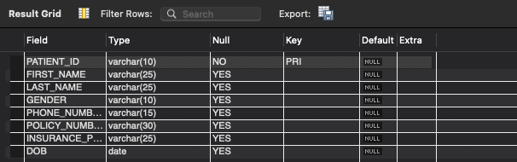

Select * from Patient
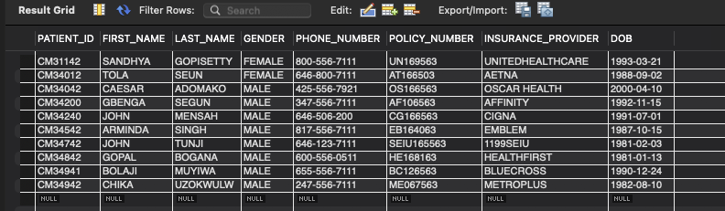

STAFF
Desc Staff
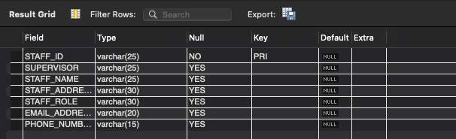
Select* from Staff
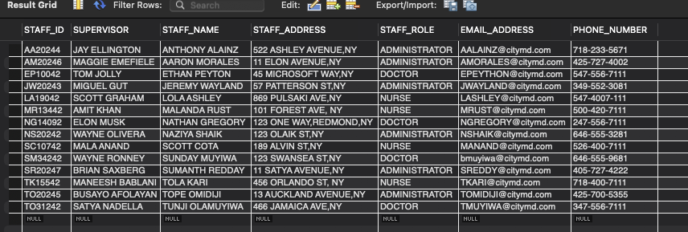

TREATMENT
Desc Treatment
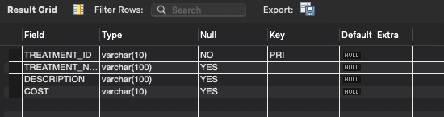
Select* from Treatment
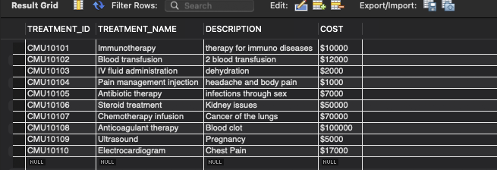

VISIT
Desc Visit
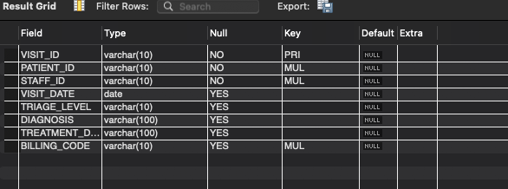
Select * from Visit
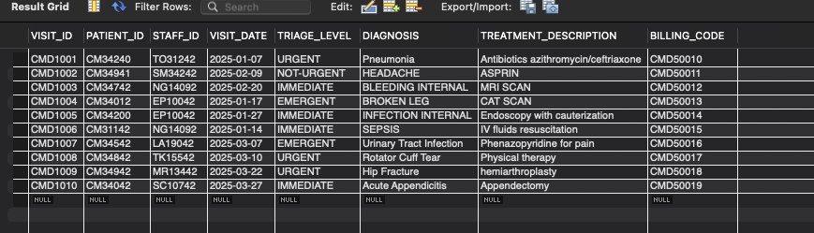

BILLING
Desc Billing
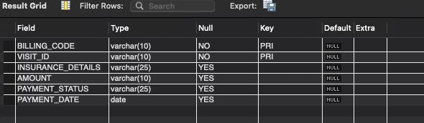
Select* from Billing
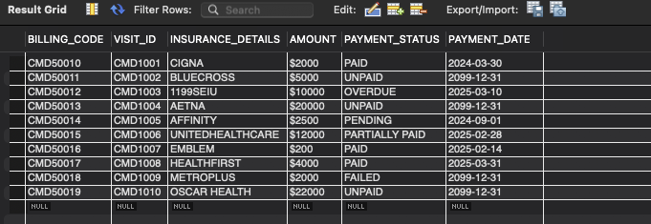

DIAGNOSTICS
Desc Diagnostics
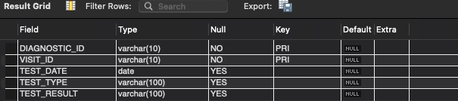
Select* from Diagnostics
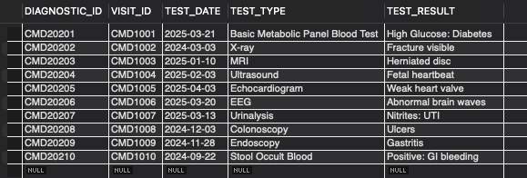

APPOINTMENT
Desc Appointment
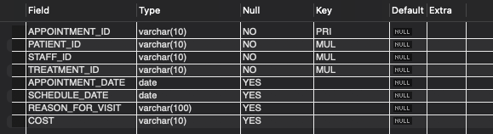
Select * from Appointment
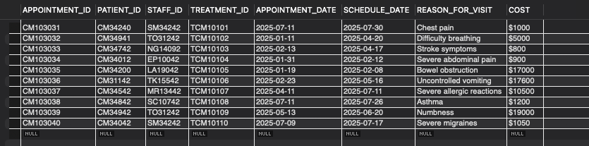

ADMINISTRATOR
Desc Administrator
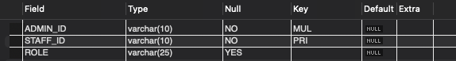
Select * from Administrator
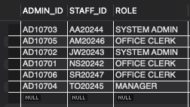

DOCTOR
Desc Doctor
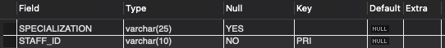
Select * from Doctor
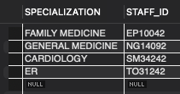

NURSE
Desc Nurse
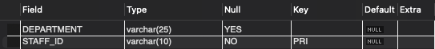
Select * from Nurse
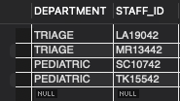

QUERIES AND JOIN
- Get all patients born after 2000 with their contact info
SELECT
PATIENT_ID,
FIRST_NAME AS patient_first_name,
LAST_NAME AS patient_last_name,
GENDER,PHONE_NUMBER
FROM PATIENT
WHERE DOB < '2000-01-01'
ORDER BY LAST_NAME, FIRST_NAME;

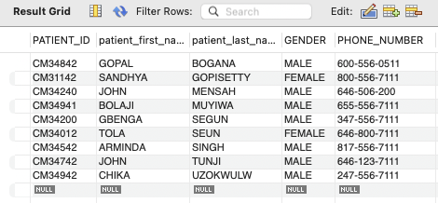

- List all appointments scheduled for JANUARY

select * from appointment;
SELECT
a.APPOINTMENT_ID,
p.FIRST_NAME AS patient_first_name,
s.STAFF_NAME AS doctor_name,
a.APPOINTMENT_DATE
FROM APPOINTMENT a
JOIN PATIENT p ON a.PATIENT_ID = p.PATIENT_ID
JOIN STAFF s ON a.STAFF_ID = s.STAFF_ID
WHERE MONTH(a.APPOINTMENT_DATE) = 1
ORDER BY a.APPOINTMENT_DATE;
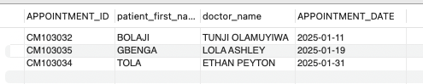

- Count how many times each treatment was given
SELECT
t.TREATMENT_NAME,
COUNT(a.APPOINTMENT_ID) AS times_used
FROM TREATMENT t
LEFT JOIN APPOINTMENT a ON t.TREATMENT_ID = a.TREATMENT_ID
GROUP BY t.TREATMENT_NAME
ORDER BY times_used DESC;

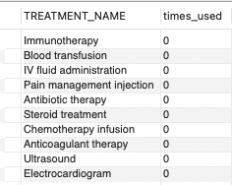

- Show all unpaid bills with patient info

SELECT
b.BILLING_CODE,
p.FIRST_NAME,
p.LAST_NAME,
b.AMOUNT,
b.PAYMENT_STATUS
FROM BILLING b
JOIN VISIT v ON b.VISIT_ID = v.VISIT_ID
JOIN PATIENT p ON v.PATIENT_ID = p.PATIENT_ID
WHERE b.PAYMENT_STATUS != 'PAID';

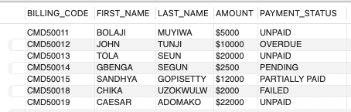

- List all doctors and their specialties

SELECT
s.STAFF_NAME AS doctor_name,
d.SPECIALIZATION
FROM DOCTOR d
JOIN STAFF s ON d.STAFF_ID = s.STAFF_ID
ORDER BY SPECIALIZATION;

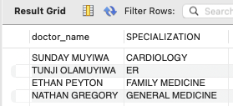

- Count doctors by specialization and show average patients per doctor

SELECT
d.SPECIALIZATION,
COUNT(s.STAFF_ID) AS number_of_doctors,
AVG(
(SELECT COUNT(*)
FROM APPOINTMENT a
WHERE a.STAFF_ID = s.STAFF_ID)
) AS avg_patients_per_doctor,
SUM(
(SELECT COUNT(*)
FROM VISIT v
WHERE v.STAFF_ID = s.STAFF_ID)
) AS total_visits_by_specialty
FROM DOCTOR d
JOIN STAFF s ON d.STAFF_ID = s.STAFF_ID
GROUP BY d.SPECIALIZATION
ORDER BY number_of_doctors DESC;

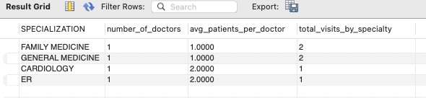

- Count the number of doctors in each specialty

SELECT
d.SPECIALIZATION,
COUNT(s.STAFF_ID) AS number_of_doctors
FROM DOCTOR d
JOIN STAFF s ON d.STAFF_ID = s.STAFF_ID
GROUP BY d.SPECIALIZATION
ORDER BY number_of_doctors DESC;

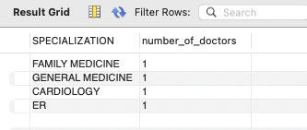

- Retrieve All Staff Members and Their Roles

SELECT STAFF_NAME, STAFF_ROLE, EMAIL_ADDRESS, PHONE_NUMBER
FROM STAFF
ORDER BY STAFF_ROLE;

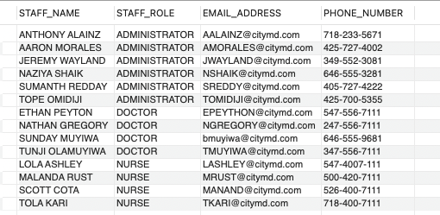

- Count Total Appointments Scheduled
SELECT COUNT(APPOINTMENT_ID) AS total_appointments
FROM APPOINTMENT;

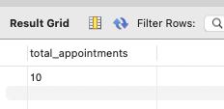

- Retrieve Patient Details with Their Appointments

SELECT p.FIRST_NAME, p.LAST_NAME, a.APPOINTMENT_DATE, a.REASON_FOR_VISIT
FROM PATIENT p
JOIN APPOINTMENT a ON p.PATIENT_ID = a.PATIENT_ID
ORDER BY a.APPOINTMENT_DATE DESC;

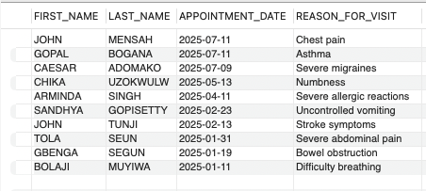

- Find Patients Who Had Diagnostics Tests with Abnormal Results

SELECT
P.FIRST_NAME,
P.LAST_NAME,
D.TEST_TYPE,
D.TEST_RESULT
FROM PATIENT P
JOIN VISIT V ON P.PATIENT_ID = V.PATIENT_ID
JOIN DIAGNOSTICS D ON V.VISIT_ID = D.VISIT_ID
WHERE D.TEST_RESULT LIKE '%Abnormal%'
ORDER BY P.LAST_NAME;

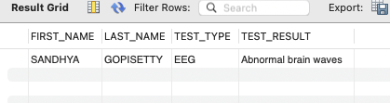

- Count of Appointments per Doctor
SELECT S.STAFF_NAME,
COUNT(A.APPOINTMENT_ID) AS Appointment_Count
FROM STAFF S
JOIN DOCTOR D ON S.STAFF_ID = D.STAFF_ID
JOIN APPOINTMENT A ON S.STAFF_ID = A.STAFF_ID
GROUP BY S.STAFF_NAME
ORDER BY Appointment_Count DESC;

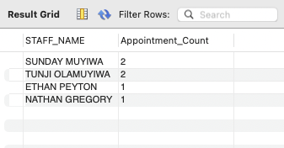

CIDM 6350 WRITTEN AND COMPLETED BY

MUYIWA BOLAJI
1126843

